WORLD ENTREPRENEURSHIP DAY CELEBRATION 2026
1. Event Overview & Inauguration
On August 21, 2026, the Department of Chemistry at M. N. College, Visnagar, organized an expert lecture titled "Chemistry of Enterprise: Transforming Chemical Insights into Commercial Innovation" to celebrate World Entrepreneurship Day. The event was organized under the head of Udisha, the Student Start-up and Innovation Policy (SSIP) Cell, and the Innovation Club. The session commenced at 12:00 PM in Room S-44, Theatre Hall, Science Building, under the leadership of Principal Dr. R. D. Modh as Chief Patron and Dr. K. M. Joshi, IQAC Coordinator and Head of the Chemistry Department, as Patron. A total of 117 participants attended the program, including 110 chemistry students (60 female students and 50 male students) along with 7 faculty members. The primary goal of the event was to motivate students to move beyond classroom chemistry and discover how laboratory science can solve real-world problems through commercial enterprise.
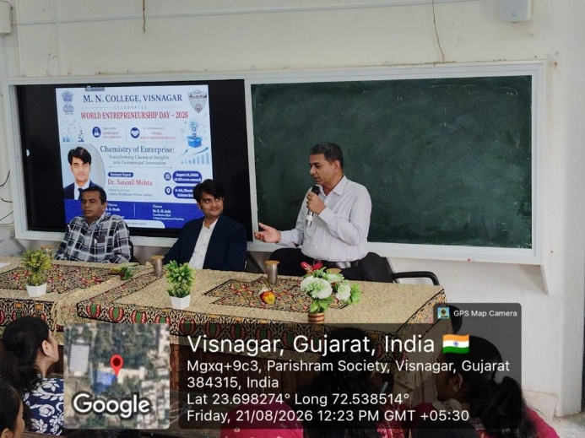
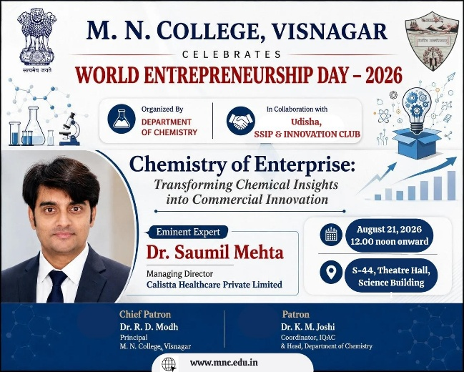

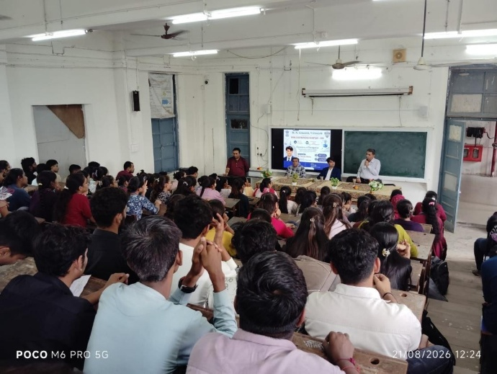
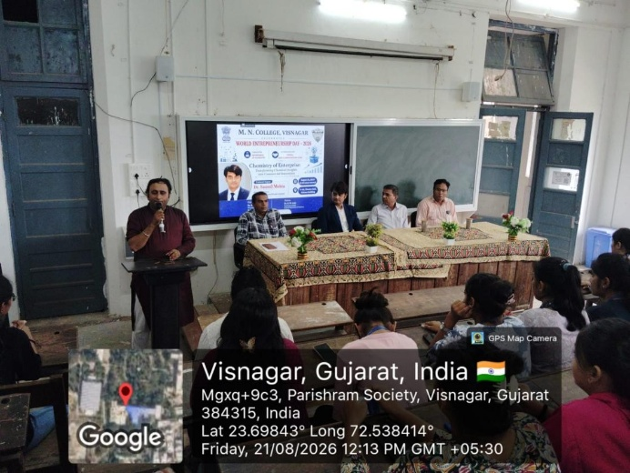

2. Keynote Address & Core Insights
The keynote address was delivered by Dr. Saumil Mehta, Managing Director of Calistta Healthcare Private Limited. Drawing from his own journey of turning academic research into a successful manufacturing company, Dr. Mehta guided the audience through the practical path of moving a product from "Beaker to Bottle". He explained that creating a formula in the laboratory is only the first step of a business. To build a successful market product, innovators must also focus on quality control, regulatory approvals, efficient packaging, production costs, and sales channels. He encouraged students to adopt a problem-first mindset by identifying genuine customer needs before developing products, and highlighted how modern technologies like Artificial Intelligence can speed up research and formula testing.
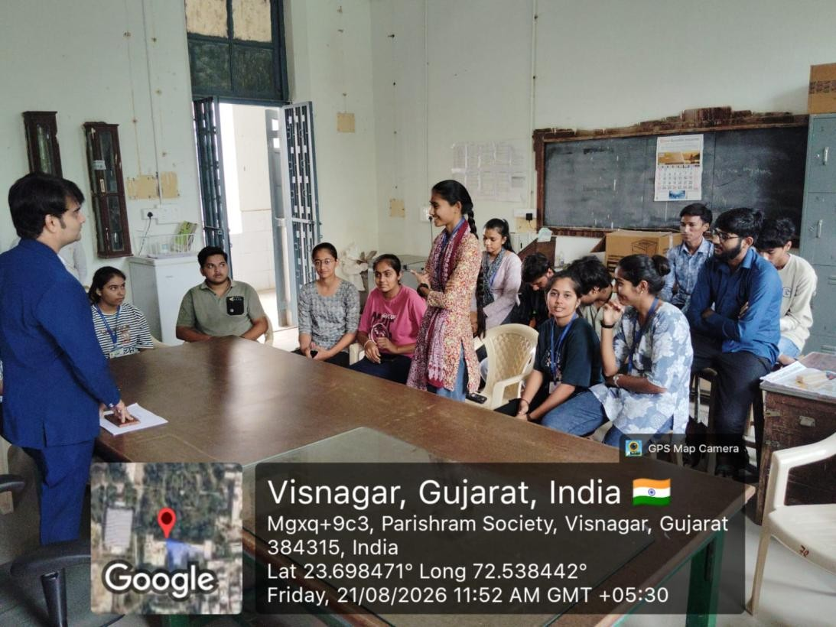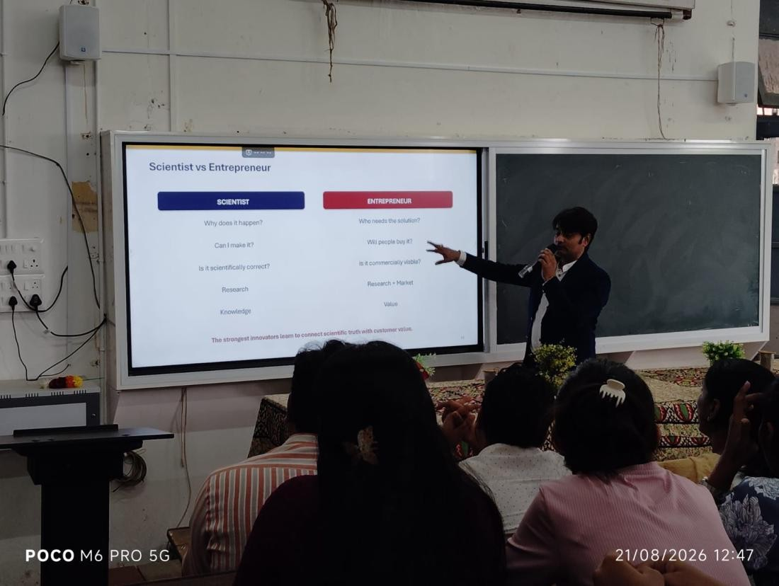
3. SSIP & Innovation Frameworks & Student Challenge
Under the head of SSIP & Innovation, Dr. Mehta detailed the essential incubation and funding support systems available to young innovators. He educated participants on how government and institutional frameworks such as SSIP, i-Hub, and MSME provide necessary seed funding, mentoring, and technical infrastructure to convert early-stage student concepts into viable startups. During the session, he highlighted high-impact sectors for chemistry startups, such as cosmetics, green agriculture, water purification, and eco-friendly cleaning formulations. To encourage active participation under the SSIP cell initiatives, Dr. Mehta issued a direct 12-month student innovation challenge to M. N. College students. He offered dedicated mentorship and industry collaboration through Calistta Healthcare Private Limited to assist students in developing market-tested prototypes.
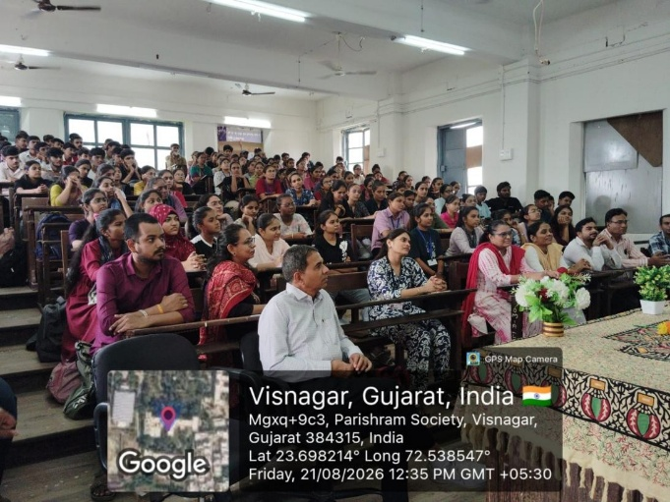
4. Conclusion & Impact
The session concluded with an active question-and-answer segment where students asked practical questions about turning chemistry projects into commercial startups. The event successfully broadened the students' perspective on career opportunities, showing them how to bridge academic learning with entrepreneurship through the SSIP and Udisha networks. By the end of the program, participants gained a clearer understanding of product development, quality control, and the support systems available to turn their laboratory ideas into viable market innovations.

Dr. Mayur Patel Dr. R. D. Modh
(SSIP Coordinator) (Principal)

